The Bavarian Motor Company

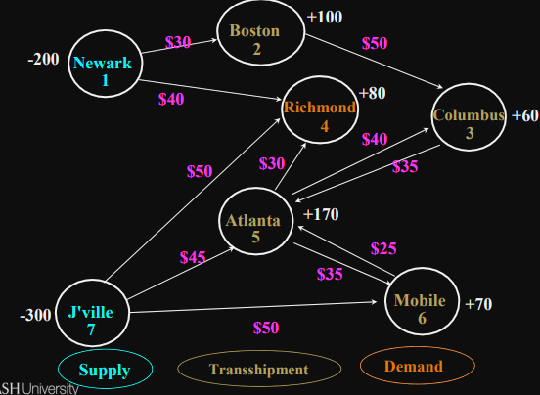

Defining the Objective Function

Minimize cost

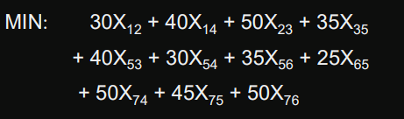

Defining the Decision Variables

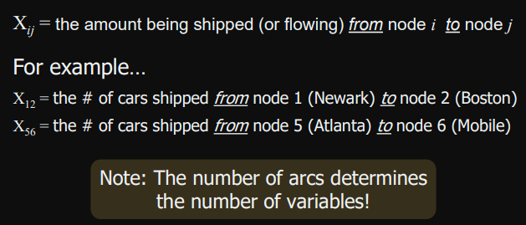

## The Shortest Path Problem

determining the shortest route or path through a network.

-Example: Emergency Vehicle Routing

This is a special case of a transhipment problem where:

* There is one supply node with a supply of -1
* There is one demand node with a demand of +1
* All other nodes have supply/demand of +0

## Generalised Network Flow Problems

gain or loss occurs in flows over arcs

– Example: Oil or gas shipped through a leaky pipeline

### Important Modelling Point

* This can make it difficult to tell if the total supply is adequate to meet the total demand.
* In generalised network flow problems, gains and/or losses associated with flows across each arc effectively increase and/or decrease the available supply.
* it is best to assume the total supply is capable of satisfying the total demand and use Solver to prove (or refute) this assumption.
* If all the demand can’t be met, another objective might be to meet as much of the demand as possible at minimum cost. To do this
  + Add an artificial supply node with an arbitrarily large amount of supply
  + Connect the artificial supply node to each demand node with arbitrarily large costs on each artificial arc.
  + This causes as much demand as possible to be met using real supply to minimize use of the expensive artificial supply.

## Maximal Flow Problem

determine the maximum amount of flow that can occur through a network

— Examples: How much water can flow through a network of pipes?

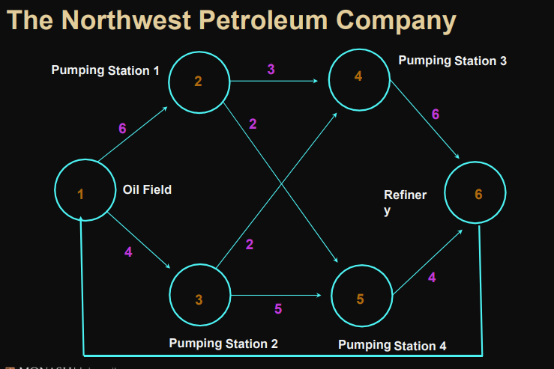

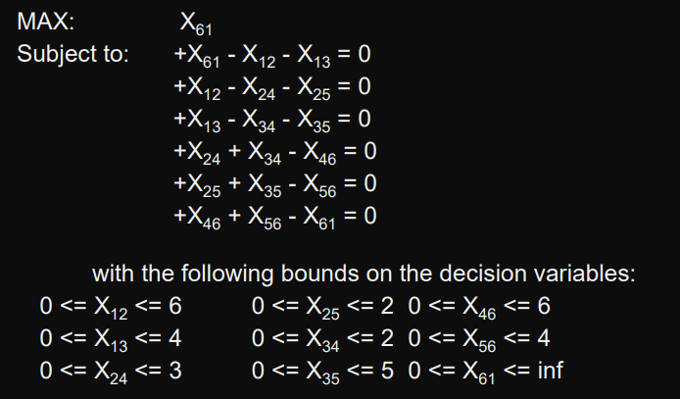

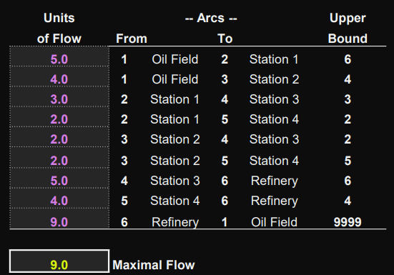

### Special Modelling- Flow Aggregation

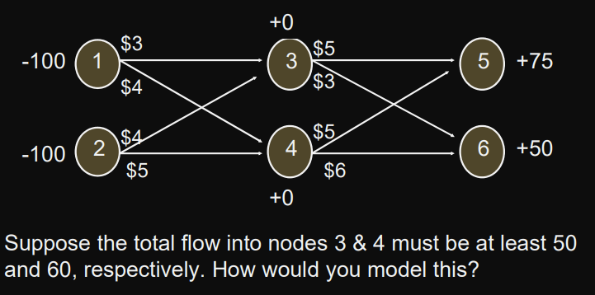

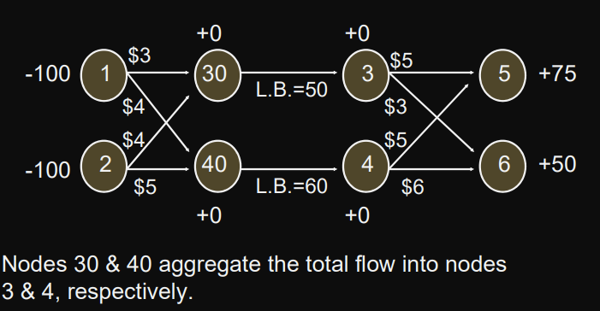

### Special Modelling- Multiple Arcs Between Nodes

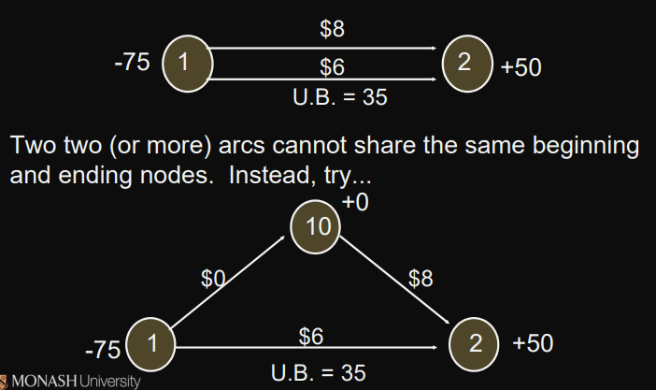

### Special Modelling- Capacity Restrictions on Total Supply

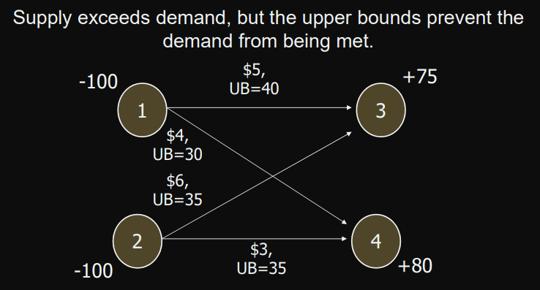

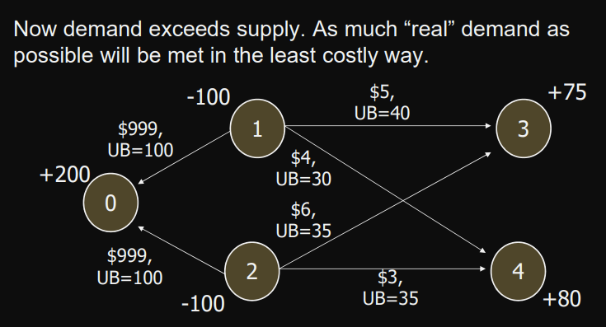

## Minimal Spanning Tree Problem

* n nodes, a spanning tree is a set of (n-1) arcs that connects all the nodes and contains no loops
* determining the set of arcs that connects all the nodes at minimum cost
* normally not use all arcs in the original network
* cannot be solved as an LP problem. However, easily solved using a manual algorithm
* Algorithm
  + Select any node
  + Add cheapest arc

